TEAM ID

NM2023TMID25744

TEAM MEMBERS ID

1. Deepa.P 8AB55623A9F5B3B88B141953E8CF8558

2. Devi .K 67BEB56B72F2F7698BD40CEE574E17B0

3. Dhanalakshmi .C 9B6013B6B647F4E825D441C7430A2B1E

4. Dharani .S D23C1FF9879F93CB96A43B1E32C44C87

Under the guidance of

Dr. A. Beulah Mary

Assistant Professor

Department of physics

Sri Meenakshi Government Arts College For Women (A)

Madurai – 625 002



PROJECT REPORT –THE TABLEAU HR SCORECARD; MEASURING SUCCESS IN TALENT MANAGEMENT

1.INTRODUCTION :

1.1 OVERVIEW:

\* The HR scorecard is meant to measure leading HR indicators of business performance.

\* Leading indicators are measurements that predict future business growth.

1.2 PURPOSE:

USES:

* Measure employee loyality and satisfaction
* Boost your HR departments efficiency .
* Tap into the intellectual potential of the company.

ACHEIVEMENTS BY USING THIS:

* An HR scorecard visually represents the critical measures of the HR departments achievement, productivity levels, and other parameters-such as hiring costs, retention rate, time to fill, quality of hire and so an-critical to the company growth.

2.PROBLEM DEFINION AND DESIGN THINKING :

2.1 Empathy Map

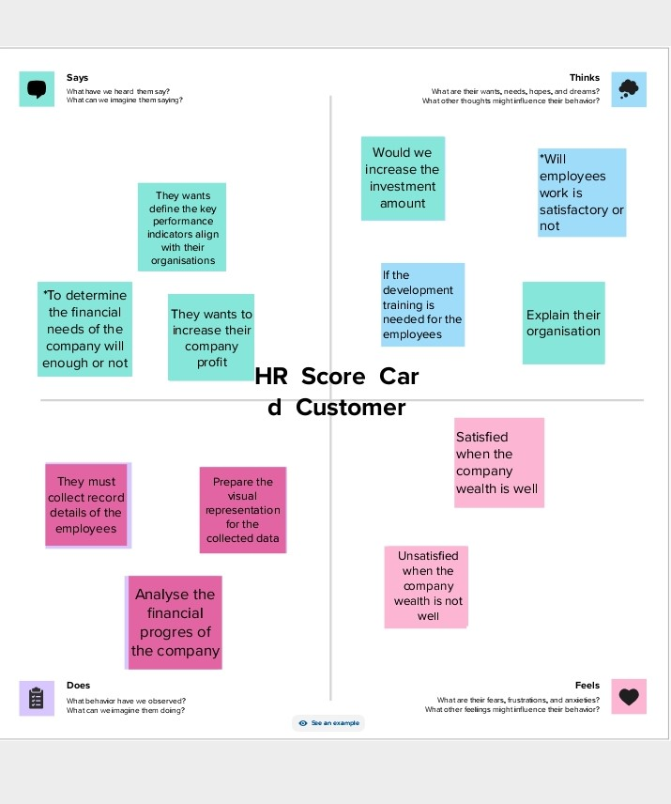 2.2 Brainstorming Map

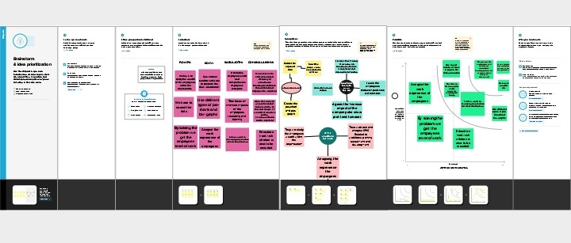

3.RESULT :

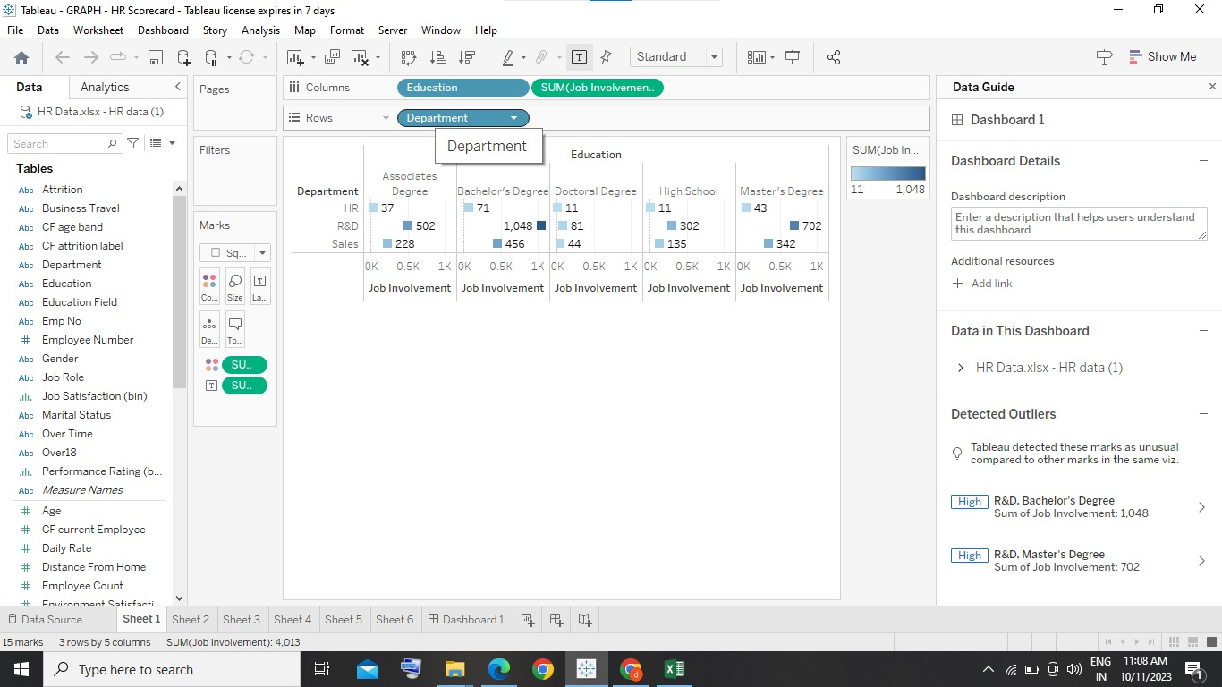

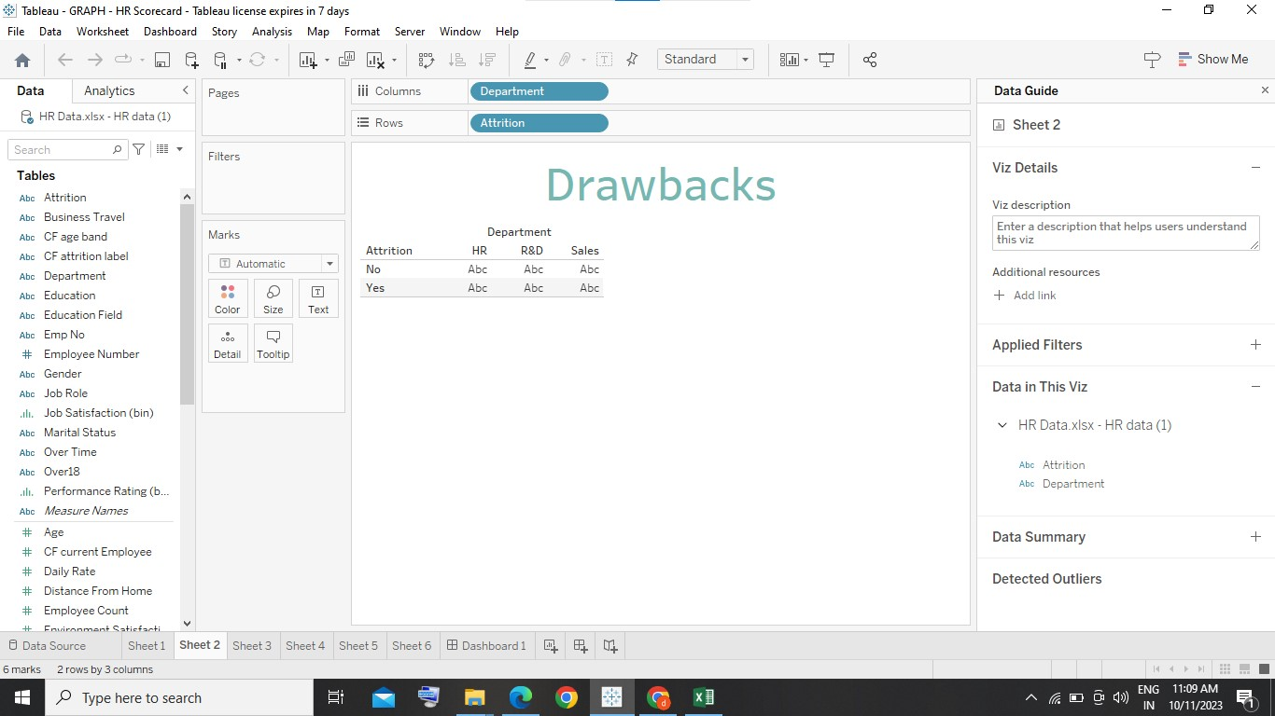

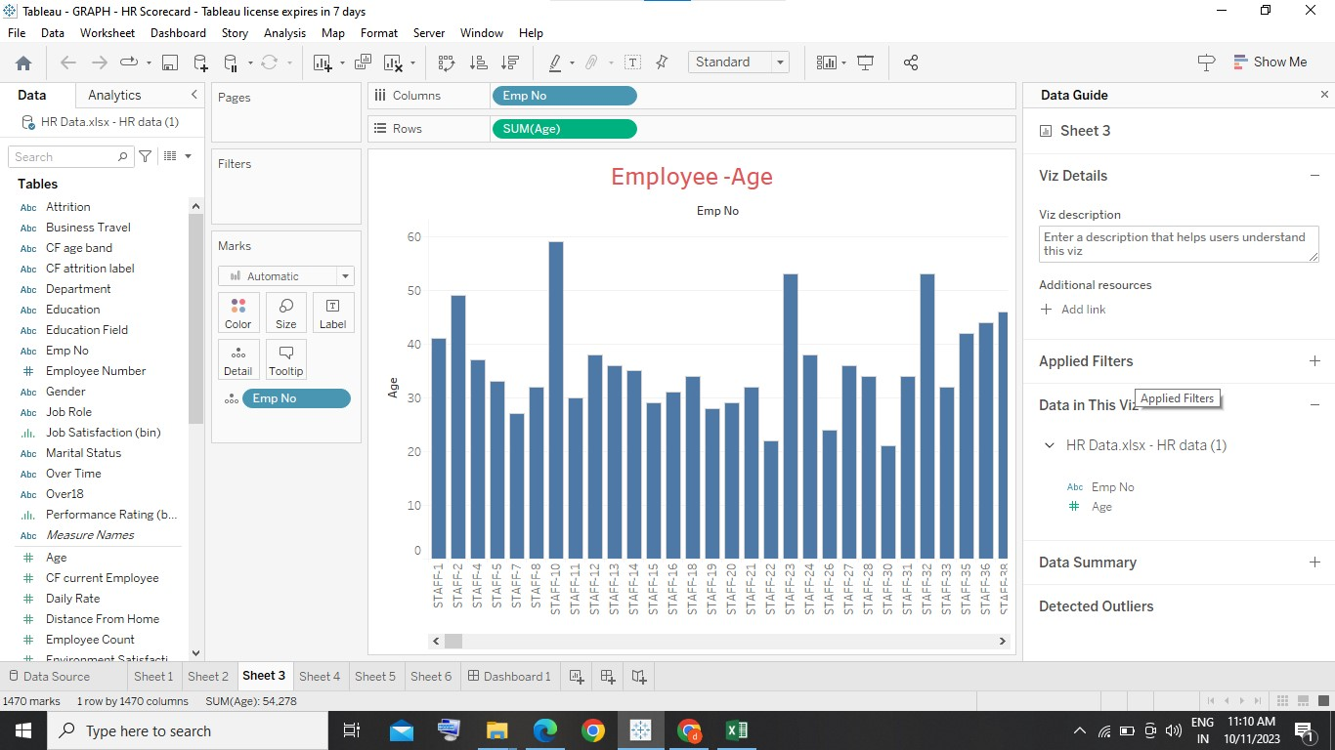

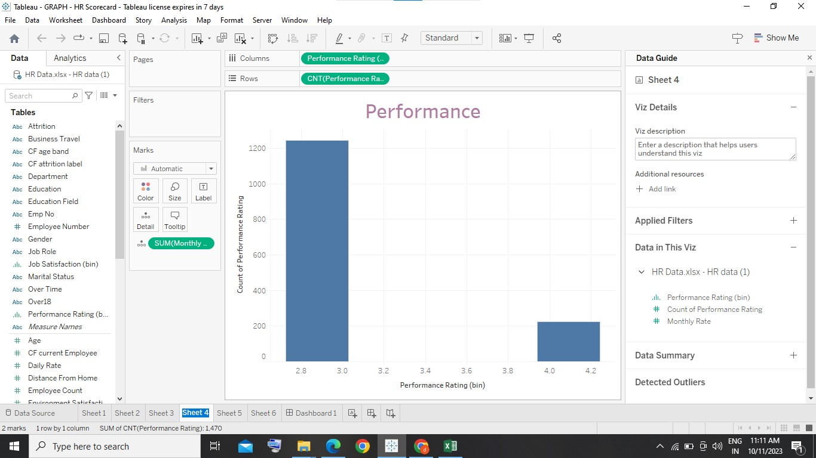

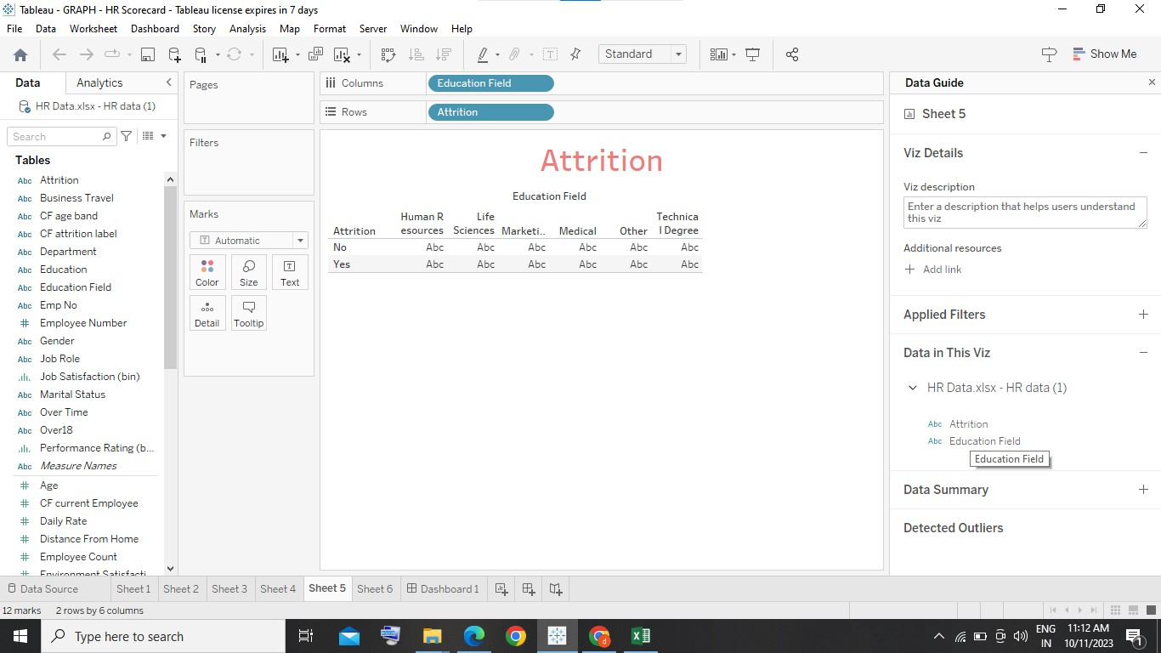

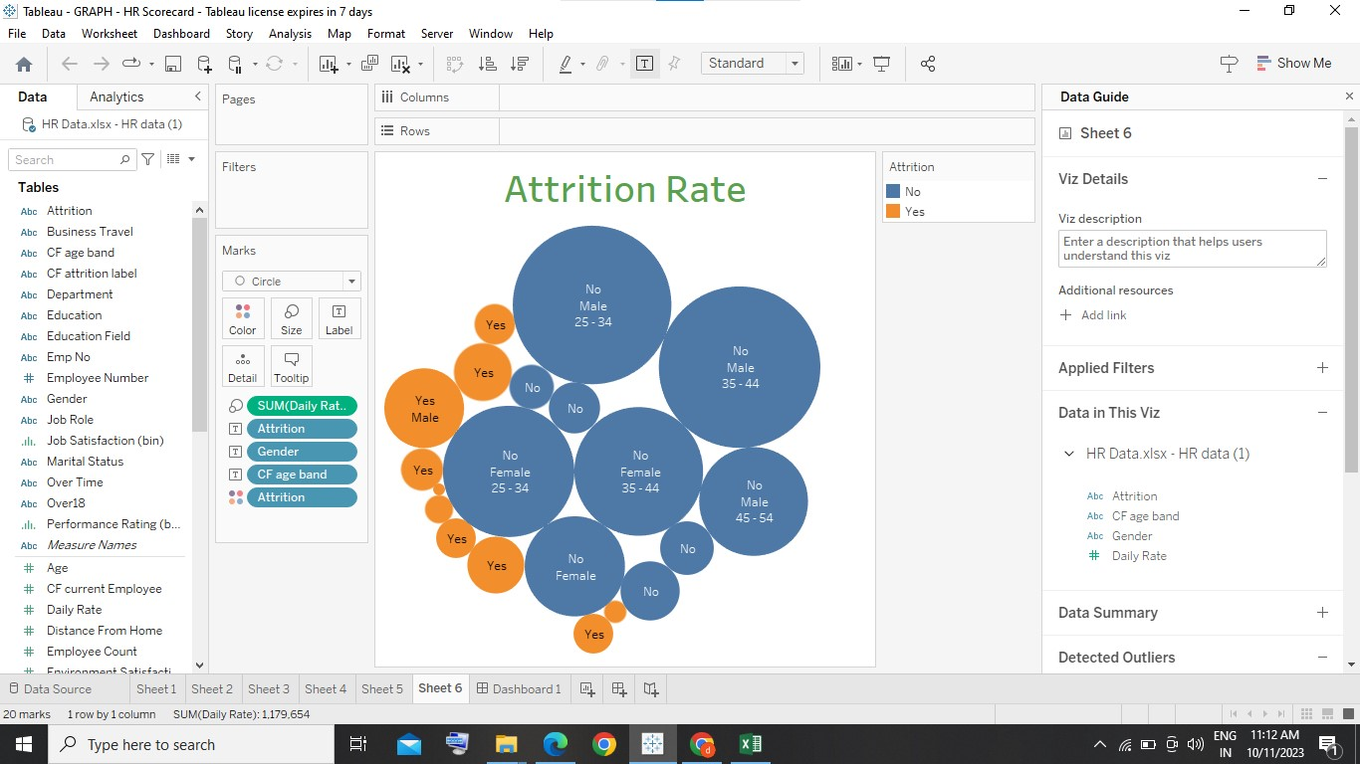

4.ADVANTAGES AND DISADVANTAGES :

Advantages :

\* Gives structure to the strategy .

\* Improves performance reporting.

\* Identify HR deliverables .

\* Define your goals and objectives .

Disadvantages :

\* It can be an overwhelming framework.

\*It may appear too rigid for the way you manage.

\*It can be difficult to keep everyone on the same page .

5.CONCLUSION :

The balanced scorecard focuses attention not only on the financial objectives of the company but also highlights the non-financial objectives that an organization must achieve in order to meet its financial objectives .A balanced argument looks at different points of view on an issue, providing arguments for and against.

6.APPLICATION:

\*Scorecards provide management with valuable insight into their firm’s service and quality in addition to its financial track record. By measuring all of these metrices, executives are able to train employees and other stakeholders and provide them with guidance and support. The balanced scorecard is a management system aimed at translating an organization’s strategic goals into a set of organizational performance objectives that, in turn, are measured, monitored and changed if necessary to ensure that an organizations strategic goals are met.

7.FUTURE SCOPE :

HR will always have a scope in future because it is a field that is constantly changing. HR in the future will be a combination of technology and people analytics . It is very dynamic field and one should never worry about scope in HR in near future. The need of HR is increasing day by day.